|  |  |  |  |
| --- | --- | --- | --- |
| **Qualification** | **BTEC Level 5 HND Diploma in Computing** | | |
| **Unit number and title** | **Unit 5: WEBDESIGN** | | |
| **Submission date** | **15- December-2019** | **Date Received 1st submission** |  |
| **Re-submission Date** | **21- December-2019** | **Date Received 2nd submission** |  |
| **Student Name** | **Bui Trung Duc** | **Student ID** | **BHAF190100** |
| **Class** | **BH-AF-1911-2.1** | **Assessor name** | **Ngo Thi Mai Loan** |
| **Student declaration**  I certify that the assignment submission is entirely my own work and I fully understand the consequences of plagiarism. I understand that making a false declaration is a form of malpractice. | | | |
|  | | **Student’s signature** | **Duc**  **Bui Trung Duc** |

**Grading grid**

|  |  |  |  |  |  |  |  |  |
| --- | --- | --- | --- | --- | --- | --- | --- | --- |
| P1 | P2 | P3 | P4 | M1 | M2 | M4 | D1 | D2 |
|  |  |  |  |  |  |  |  |  |



Table of Contents

A. Introduction 3

B. Content 4

I. A review of appreciate web design principles, standards and guidelines 4

**1.** **Design document for online shopping website** 4

**2.** **Implementation of website design** 8

II. Create and use a Test Plan to review the performance and design of a multipage website 10

**1.** **Test UI (include color, layout, font, image)** 10

**2.** **Test UX (when open the website on a variety of devices)** 10

**3.** **Test log** 11

III. User manual and Solution 11

IV. Compare and contrast the multi-page website created to the design document 13

V. Evaluate the quality assurance (QA) process in website design and how it was implemented during your design and development stages. 14

VI. Practice 18

C. CONCLUSION 22

D. References 23

# **Introduction**

Wireless, public hotspots, mobile broadband, and unlimited network connections mean that accessing and using the internet to request, use and post information has never been so easy, or so important. As a public, organisational and business demand increases, so do user expectation. Designers need to successfully use technology to deliver high quality and consistent User Experiences (UX) through friendly and functional User Interfaces (UI). However, as the software and hardware evolve, so does the challenge of design.

This unit introduces students to the underpinning services required to host, manage and access a secure website before introducing and exploring the methods used by designers and developers to blend back-end technologies (server-side) with front-end technologies (client-side). To help ensure new designers are able to design and deliver a site that offers an outstanding User Experience (UX) supported by an innovative User Interface (UI) this unit also discusses the reasons, requirements, relationships, capabilities and features of the systems they will be using and gives them an opportunity to explore various tools, techniques and technologies with ‘good design’ principles to plan, design and review a multipage website.

Among the topics included in this unit are: domain structure, domain name systems, web protocols, database servers, development frameworks, website publishing, content management, search engine optimisation, web browsers, HTML standards, CSS and CSS pre-processing (LESS, SASS), presentation models, responsive design, integrated development environments, user requirements, interface design, user experience, branding, navigation, optimisation and validation.

On successful completion of this unit students will be able to explain server technologies and management services associated with the hosting and management of secure websites, categorise website technologies, tools and software used to develop websites, utilise website technologies, tools and techniques with good design principles to create a multipage website and create and use a Test Plan to review the performance and design of a multipage website. As a result, they will develop skills such as communication literacy, critical thinking, analysis, reasoning and interpretation, which are crucial for gaining.

1. **Content**
2. **A review of appreciate web design principles, standards and guidelines**
3. **Design document for online shopping website**
   1. **Database Design**

* Choosing the right technology to create your new database using best in class technologies such as Microsoft SQL Server
* Correctly assessing data storage and bandwidth requirements
* Projecting growth in number of concurrent users and data volumes
* Considering data protection and security requirements
* Researching database integration with third party systems and services
* Choosing the right data reporting tools
* Analysing data import and export requirements
* All of our database design specialists have many years of experience working with Microsoft database platforms such as Microsoft SQL Server and Microsoft Access.
* We can demonstrate similar projects from our extensive portfolio to help you visualise what your database will look like and how it will function. You can ask us for non-binding cost andm timescale estimates as well at this stage to help you make informed choices based on your requirements and their potential cost.

**Key stages of the database design process:**

* Identify user requirements
* Choose an appropriate database technology
* Create wireframes and process flow diagrams
* Create data tables structure
* Create user interface visuals
* Create database prototype
* Finalise functional and non-functional requirements with stakeholders
* Finalise reporting requirements
* Agree delivery programme and timescales
* Commence development
* Database design facts in a nutshell
* A database consists of related entities that may interact with each other in a workflow.
* Example of a database entity:
* Each database entity can have a number of properties for example; a customer entity could have properties such as customer name, address, and phone number.
* Some of these properties may have to be unique to allow the database to identify the correct record as requested by a user.
* Unique properties could be a customer ID or an order number.
* Sometimes, when there are no obvious unique identifiers, a database designer must introduce a new property, such as an auto ID field to make records unique.
* Entities may have relationships. For example, a contact record can be linked to a customer record and an invoice record would be linked to an order record.
* Entities may also interact with each other in a workflow. For instance, an enquiry could be transformed into an order and an order would be transformed into an invoice.
* The database design process typically involves two people – a business analyst and a database designer.
* The business analyst works with business stakeholders to identify present and possibly future database entities, their respective properties, and workflows. The analyst will also study existing workflow management tools, such as Microsoft Excel or third party systems, to analyse how data is currently collected, processed, stored, and reported upon. Analysing existing reporting requirements is key to understanding how stakeholders expect to receive information from the database and ensures that the database designer captures and presents all the relevant data stored within the database.
* The designer will request data samples to identify the properties of each entity. Typically, each property will have a corresponding field in the database. For example, a product may have fields for colour, weight, or price. Each field value should have a correct field type in order for the database to be able to process data correctly. Field types can be numeric, text, date, etc. Establishing the correct data types is essential, allowing the database to manipulate the data accurately.

**Database designers need to take into account a variety of factors, including:**

* The amount of data that the customer is going to store in the foreseeable, as well as the very distant future
* The number of concurrent users and anticipated growth rate
* How users are expecting to access their data, for example using web browsers, desktops, or handhelds
* Where the database must reside, i.e. office server, cloud etc.
* The database designer should also ensure the security of the customer’s data. This involves establishing access levels and defining user permissions for different user groups in the organisation.
* Database access can be restricted by IP address, so that only specific end points can gain access to the database.
* The customer may also wish to safeguard some of their most sensitive data by using encryption to reduce the risk of their data ending up in the wrong hands, as well as to comply with the data protection laws and regulations.
  1. **Illustrate the structure and components of website (use Wireframe)**
* Wireframe is a visual tool for web design at the structural level. A wireframe is typically used to arrange content and functionality on a page. Wireframe is also used in the process of setting up the basic structure of a website before visual design.

**Header**

* This element is located at the top of the web page and is displayed on all pages of the website.
* The header usually contains the following components:
* Site ID
* Home link
* Navigation menu
* Search box
* Cart

**Site ID**

* An identifier for a website, easier to understand than a website name.
* Site ID is usually located in the left-hand corner.
* You can easily see the logo or a short slogan for the website.

**Home link**

* Home link, also known as a link to the home page,
* when you click on this link will redirect to the homepage of the website.

**Navigation menu**

* This is the container for the collection of links to the main pages of the website. Usually the menu will be placed inside the header.
* The menu is designed with easy to see, helping users to quickly go to the main pages on the website.
* For example, you can see the menu can include the following links: Home, Product, Contact, Introduction ...
* Sometimes the menu is also placed at Scan columns or Footer, these elements you will see in the next section.

**Search box (Search box)**

* For websites with lots of articles or products, the search box helps users find information on the website quickly.
* In the header, the search box is usually placed in the right corner and made simple to not take up much space.
* It includes only one box to enter the search term and a search button.
* If you think of a search box with more functions such as product category search, color (usually called advanced search), think about setting it at Scan columns

**Cart**

* For shopping websites, you will notice a shopping cart icon located on the right corner.
* The shopping cart can display information such as: number of selected products, how much total? When the user clicks on it will be redirected to the cart page to see details of the products ordered.

**Slider**

* This element is usually located below the header. Common sliders are images, which contain many different images, but not all on the web page.
* The slider will have a navigation button, allowing you to scroll through other slides. Also slides can be videos.
* The well-designed slider will engage your customers on the first visit to the website. Today, you can see slides on a lot of different web pages.

**Scan columns**

* Why is called "scan columns", scan is like you use your eye to go through each part of the web page, which is specifically here are columns.
* The concept of scan columns has existed for a long time, before that, it was used in book publishing. Today scan columns are widely used in website design.
* The common types of column division you often come across are dividing 2 columns, 3 columns ...

**Scan column usually takes up not too much width, it may contain the following components:**

* Navigation menu
* Advanced search box
* Featured products, articles
* Contact information
* Advertising banner

**Banner**

* There are some cases of confusion between banner and header. Actually the banner and header are completely different.
* The word banner is used in advertising such as advertising products, advertising events Banner normally will be an image, eye-catching design to attract customers.
* Common banner placements like the top of the page (above the header) or in the scan
* Also you can see banner ads in video clips such as youtube.

**Page footers**

* Also known as footer, is located at the bottom of the web page and is displayed on all pages of your website.
* The footer typically contains the following elements:
* Website copyright information
* Link link
* Menu

1. **Implementation of website design**

**Describe how to create website (include IDE, language to develop website)**

* Step 1: Set up a local working environment
* Step 2: Plan and design your Website with Adobe Photoshop
* Step 3: Codify designs using HTML and CSS
* Step 4: Make it dynamic using JavaScript and jQuery
* Step 5: Upload the local file to the server using an FTP clien
* For creating and organizing a website's source files, a good local work environment is important.
* You can create a web development environment on your desktop device by installing an IDE (Integrated Development Environment).
* An IDE essentially consists of a Text Editor, Build Automation, and Debugger.
* Subheading and Atomic are some of the basic IDEs for web development that support HTML, CSS, JS, PHP, Python, and similar web languages.
* On the other hand, there are extended IDEs like Adobe Dreamweaver that provide a few

**Describle how your website works**

* Dynamic website is understood in a direct way that the content on the website can be "dynamic". This type of website is also built and programmed by HTML5, CSS3 and Javascript but with the presence of a server programming language like ASP.NET, PHP, ... and a database like SQL Server, My. SQL, ...
* With a dynamic website, users will be provided with an administration tool that allows quick and simple changes to the external content.
* So basically we can distinguish between dynamic and static websites as follows:
* Same: Both built in HTML5, CSS3 and Javascript
* Various: (see detailed breakdown below )

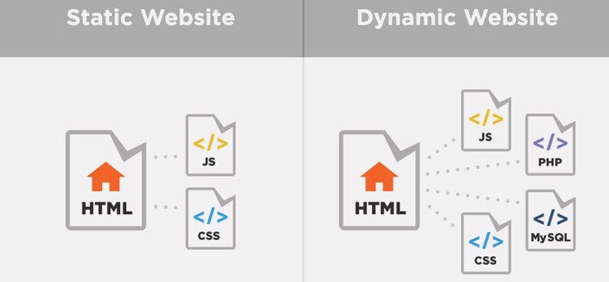

Figure 13: Distinguish static website and dynamic website

Website static

* Do not allow users to interact with the website, information that needs to be changed on the website needs direct intervention to edit on the HTML file.
* Difficulty in maintenance and upgrading
* Low cost of website design
* Beautiful interface

Website dynamic

- There are more Server programming languages such as ASP.NET, PHP, ... and database SQL Server, MySQL, ...

- Allows users to interact with the website

- Easy to maintain and upgrade website

- High cost of website design

- High application: Design website for sales, design real estate website, design website for business

1. **Create and use a Test Plan to review the performance and design of a multipage website**

### **Test UI (include color, layout, font, image)**

**Necessary**

* Eliminate unimportant components: If the elements do not improve the quality of the customer experience, please remove them immediately or move on to another section, to avoid gathering more on the homepage.
* Simplified pull-out menu: Small selection items in the menu you should minimize to 7 items because if too many will still make the interface dense, lack of professionalism.

**Unnecessary**

* Use slides: Many visual motion effects using slides on the homepage are easy to distract the user. Reasonable choices are still good quality and computational images. From there, users will focus on the content rather than on the unnecessary elements.
* Use of the sidebar: Sidebar is an element that many users when visiting the website will most not click on. So, you do not need to use the sidebar because it is not very efficient but it does not fit the screen when switching the web int

1. **Test UX (when open the website on a variety of devices)**

**General features:**

* Providing SaaS service, pay by hour or by month.
* Allows to run simultaneously on multiple real or virtual devices
* Test scripts can be in 3 forms: direct interaction on web browser (running slowly), automation (automatically creating test scripts and filling test data into forms) and programming (creating scripts according to test scripts).
* The results are returned in the form of: screenshot, screen recording video, results
* Tested for both Android and iOs, using apk or ipa export file

**Strength:**

* Inheriting the strengths of cloud, this approach can be used without a
* Investment on / off and on-demand payments.
* Environment parameters can be configured easily.
* Run a variety of devices, run automatically without a lot of human effort, resulting in visual videos and screenshots.

**Weakness:**

* Only supports big and popular brands, does not support testing on floating and weaker devices such as Oppo, Xiaomi, Huawei, Pantech .. but now the proportion of these devices in Vietnam is very large. .
* The pass / fail result returned does not have much value because the fail condition cannot be configured, so the automatic running is ineffective, must be analyzed by itself on the video.
* Operating costs (Opex) are not small, up to from 100 USD / month.

1. **Test log**

Step 1: You go to Configuration> Activity Log

Step 2: Search manipulation by time, employee, function, action, ...

Step 3: Click on the employee's name to view details of operations and equipment used.

1. **User manual and Solution**

**How to open an online shop in just 6 steps**

1. Online business planning

2. Register online business

3. Create a website for an online shop with an e-commerce platform

4. Customize online website design

5. Set up website online

6. Online shop promotion

Added: Customize online shop

1. **Add product**

* To create your first product, visit Products -> Add New on your WordPress dashboard. You will be redirected to a page like the default post edit screen. Here, you can insert product name and description as follows:
* On the right side of the page, select the tag and category for the product. You can also place a Product image or upload multiple images to the Products gallery to display products from different angles. Make sure to use high-quality photos.

1. **Configure Product Page**

* The product page is where all of your items are displayed. Being organized and engaging can help you determine whether your visitors should explore your site further.
* With that, we'll show you a quick guide on how to set up a product page on WooCommerce.
* If you go through WooCommerce Setup Wizard, the plugin will create a Product page called Shop for you. However, if you skip the setup section, here's what you need to do:
* Go to the control panel and choose Pages -> Add New.
* Put the name of your page in the Title bar. You can call it ‘Products,’ ‘Shop,’ ‘Store,’ or other similar options.
* Click Publish.
* On the left menu, go to WooCommerce -> Settings and go to the Products tab.
* In the Shop page field, select the page you just created.

1. **Payment processing setup**

* One popular option is PayPal. Because it's so widely used, using PayPal will make your store accessible to many shoppers. Plus, it allows users without a PayPal account to pay with an alternative credit card.
* For online businesses, you will need a secure payment gateway to handle money from customers.

1. **Epilogue**

Thanks to the internet, an online shop business no longer needs retail space. Online services like web hosting and e-commerce platforms can make it easy to start any business.

In this article, we discussed how to start an online shop in 6 steps, which are:

1. Online business planning
2. Business Registration
3. Create a website with an ecommerce platform
4. Custom website design
5. Set up an online shop
6. Reach out to customers

* As long as you provide the best shopping experience to your customers, your online shop will be successful. So start your business today with Hostinger and wish you luck.

Where does the sales web design appeal to internet users:

* Eye-catching interface, showing the professionalism in both appearance and quality of your products and services.
* Website loading speed quickly, avoid customers waiting to see your product, they will not be patient enough, they will exit and go elsewhere. So make sure your website speed is no more than 3s.
* Dividing categories and products clearly, let customers find what they want to buy easily.
* Manipulation of purchases easily and quickly on both computers and mobile phones. Website must be designed standard SEO, friendly with google and search engines
* Optimized interface displayed on all devices
* Website is absolutely secure
* The content management page, product administration is simple and easy to use
* Especially, the website is easy to upgrade and add functions later

The advantages that we can do when designing a website to sell online to customers.

* Designing an online business website will optimize a standard seo website.
* Sales web service is also optimized for mobile standards, compatible with all devices.
* Extremely fast page loading speed.
* Cheap website design compared to the market today.
* Website design is made with eye-catching interface, bringing the unique style of each business.
* The security of the website is highly optimized.
* Design a multi-language website to sell goods to foreign customer

1. **Compare and contrast the multi-page website created to the design document**

* A multi-page website contains multiple pages and subpages within a menu. Unlike the single page website, the only way to navigate to and view pages in multi-page design is to click on the links within the menu.
* The multi-page design is well-suited to nearly every type of project. Examples of multi-page web design can be found in eCommerce sites (such as Amazon), dashboards (such as Atlassian) and eLearning sites (such as Lynda).

1. **The pros of multipage website design**

* There are three main advantages of the multi-page over the single page website.
* Firstly, multi-page design offers unlimited scalability. Create as many pages as you like and expand the navigation system as needed. For instance, swap your top navigation bar for a custom mega menu with a search bar for endless navigation possibilities. Remember, the type of navigation design you opt for will depend on the depth of your website goes, the more a traditional navigation will struggle.
* Secondly, the navigation flow of a multi-page site is easy to follow. This type of website has been around since the 90s, which means that most users are familiar with it, and often expect to find multiple pages on sites. As long as your website’s navigation flow is easy to follow, you’re smooth sailing with a multi-page design.
* Finally, sites with several pages have powerful SEO capabilities. We’ve established that multi-page sites are more likely to have larger amounts of content than those with a single page. And although the SEO potential of each website heavily relies on your digital marketing strategy, just having the content potential to optimize your SEO is a great start.

1. **The cons of multi-page website design**

* Multi-page websites seem to have worked for us up until now, but there are a few disadvantages to take into account.
* For instance, consider how you’ll manage regular updates to your site. Don’t forget that all that content needs to be maintained by the design and content teams. Whenconsidering whether to design a one page or multi-page website, you need to think about whether having lots of content is cost-effective. And remember that low quality or under-optimized content is just plain bad for business.
* Another thing to take into consideration is your site’s bounce rate. Websites with heavy amounts of content are often slow-loading, distracting, and can cause users to bounce– according to Search Engine Journal. And although not every multi-page website is content-heavy, with all that room to scale, it’s something to look out for.
* Finally, multi-page design is harder to adapt to mobile. Unlike single page sites, where the same backend code can be used to develop the mobile site, multi-page designs need to be started from scratch to produce the mobile version. Not only is this more costly and time-consuming, but you risk losing design consistency across web and mobile platforms.

1. **Evaluate the quality assurance (QA) process in website design and how it was implemented during your design and development stages.**
2. **QA Process and Development Steps**

Initially, QA helps design and control the development process in a way that prevent serious issues during the project. To make this happen, QA engineers work on the project together with other team members (product owner, project manager, business analyst, and dev lead) throughout the complete software development cycle. The number and the order of QA activities may vary from project to project, depending heavily on the scope.

* 1. **Development process**
* Analysis of requirements
* Design
* Implementation
* Verification or testing
* Maintenance
  1. **QA process**
  + Review of requirements
  + Test planning / writing test cases
  + Unit testing
  + Integration testing
  + System testing
  + Performance testing
  + Security testing
  + Cross-browser testing / cross-platform testing
  + Updating test cases
  + Regression testing
  1. **Connection of QA process and development process**
  + Let’s have a deeper look at QA processes and how they are connected with the development steps.

**Step one: review requirements and documentation.**

* + QA engineers start their work on the project in parallel with documentation generation.
  + They review the requirements and documentation for:
    - completeness
    - redundancies
  + clarity
  + consistency
  + executability
  + verifiability
  + The aim is to analyze system architecture and technologies for discrepancies.
  + Key benefits for the development process:
  + Errors cost less when detected at an early stage
  + Improved documentation means a higher quality project for lower labor input and more accurate estimates.
  + For this step, think about using specialized software for documentation review, like
  + Confluence. You can gather all related documentation which is used throughout the whole project, and maintain an internal knowledge base. Every team member can see any changes as soon as any requirements or documents are changed, added, updated, or deleted.

**Step two: plan and prepare test cases**

* + When the requirements have been established, it is time to start planning test cases, i.e. describe the actions QA engineers perform to make sure the piece of software functions as
  + planned. In case the volume of such cases turns to be really significant, you can also use special tools like TestRail or Zephyr for writing test cases. Both pieces of software allow creation and modification of tests, and track results using metrics.

**Step three: design test cases**

* + When the development stage is finished, the QA team starts running the test cases. The main goal of this stage is to check whether the solution is developed properly from the technical perspective and meets the initial product owner’s requirements.
  + Below are the main QA activities and their aims:
  + Smoke testing comes first. QA engineers lightly check that the software, or its module, functions as planned. When passed, the further investigation begins.
  + Integration testing – verify that different components work as a single system.
  + Performance testing that includes:
  + Load testing – check system behavior for normal and expected peak load
  + Stress testing – determine critical load after which the system breaks down
  + Security testing – ensure the solution has a sufficient protection level.
  + Cross-browser testing/cross-platform testing – check that the software works smoothly on different browsers (Chrome, Mozilla, Safari) or platforms (Android, iOS, Win Phone).
  + This is especially important for web and hybrid apps.
  + Regression testing – detect bugs in the code that was tested previously.
  + Usually needed when adding new features or making any updates to an existing system.
  + Again, you can choose to automate the testing (e.g., unit testing, regression testing).
  + The general rule: the longer a project lasts, the more it needs automated tests.

**Step four: report and measure**

* + When a QA engineer discovers a bug, he/she records it in a bug tracking system which is also a project management system. For this purpose, you may use Jira or Redmine, both being highly configurable software. They enable easy tracking of issues of any level, from a broken login form to security problems, and all team members can see real-time task updates.
  + This simplifies communication inside the team and helps keep a clear overview of the improvement process.
  + Each issue gets a priority level from urgent to low, which the development team then resolves based on time and people available.

**Step five: verifying fixes**

* + When a developer fixes an issue he/she informs the responsible QA engineers, who verify it.
  + The ticket in the bug tracking system is closed when no issue is detected. This rule applies: no bug can be marked as fixed until it is verified

1. **Practice**

**Form Login**

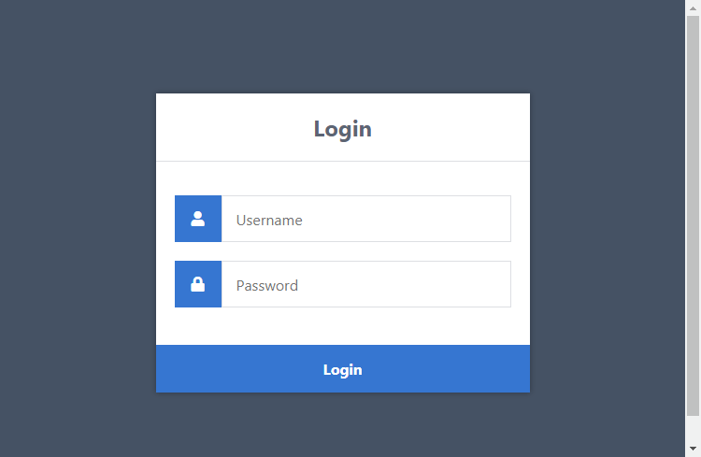

Login Form

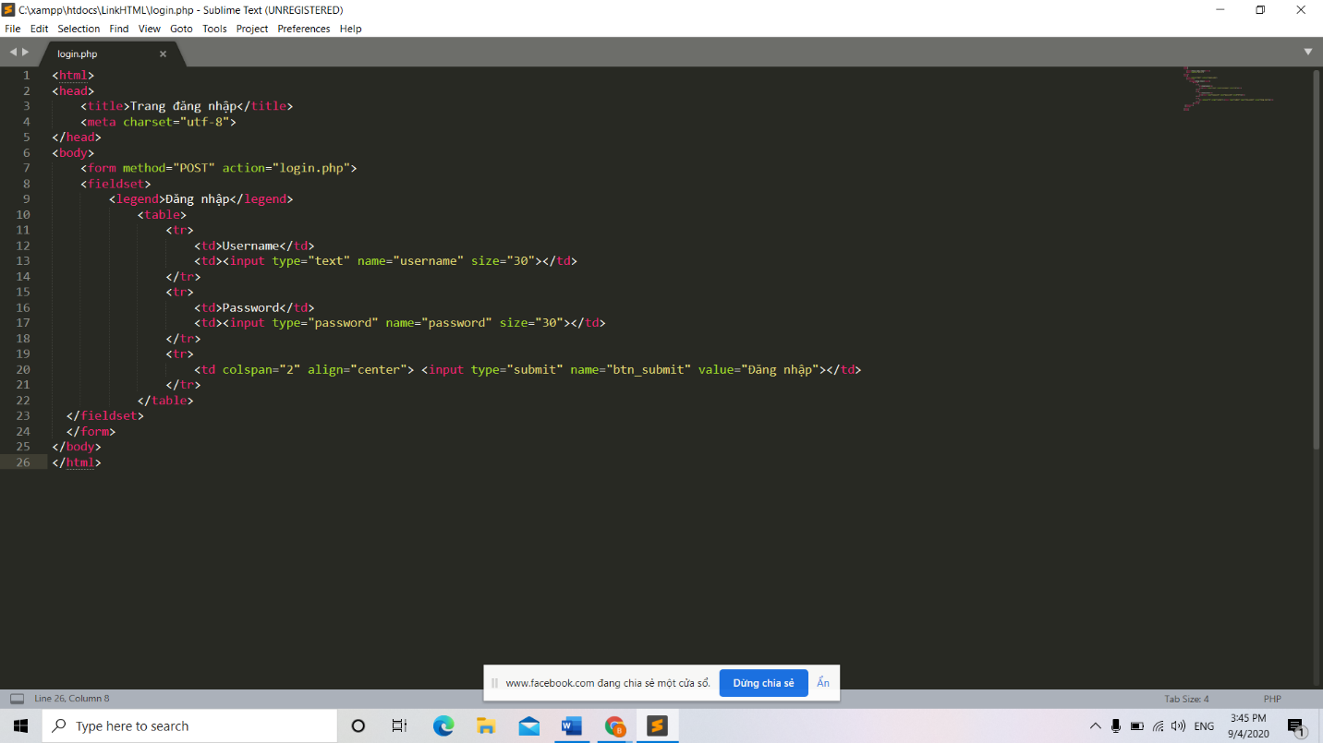

Code login form

**Form Register**

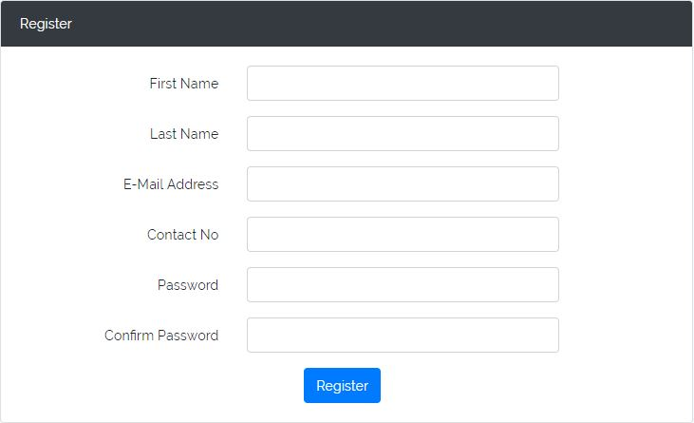

Form Register

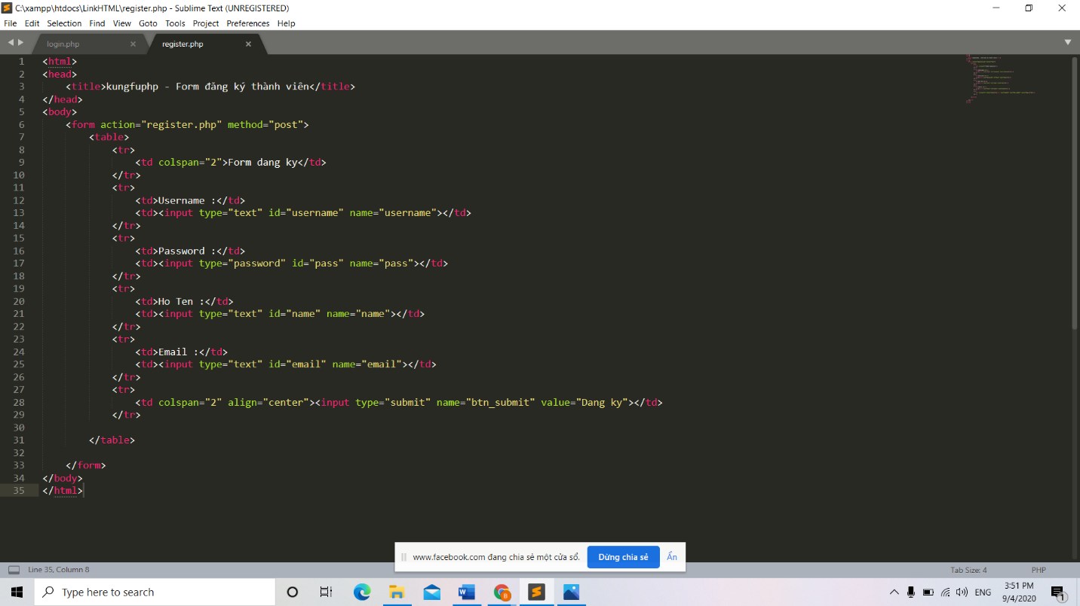

Code Register

**Form logout**

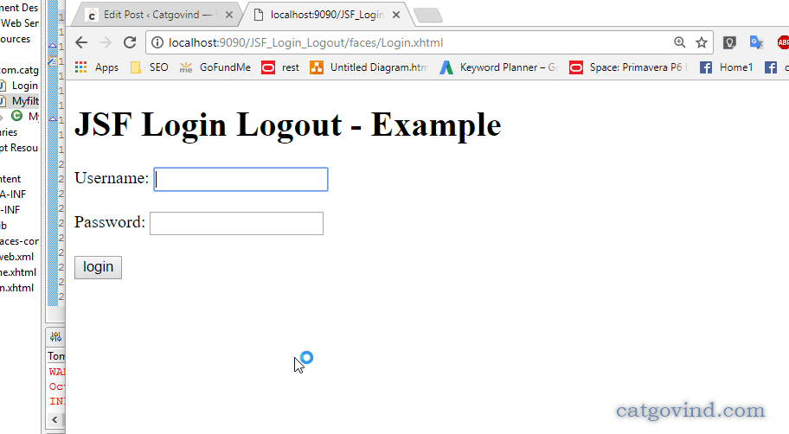

Logout form

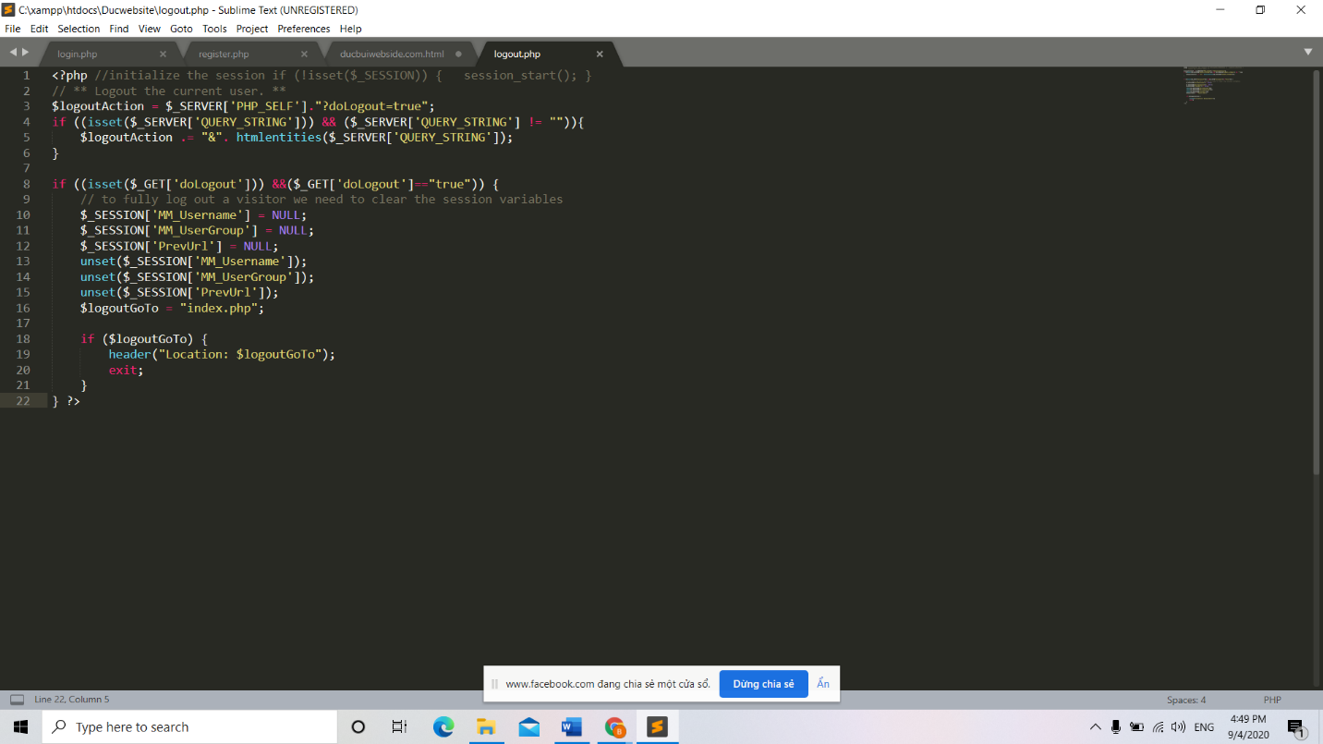

Logout code

**Add product**

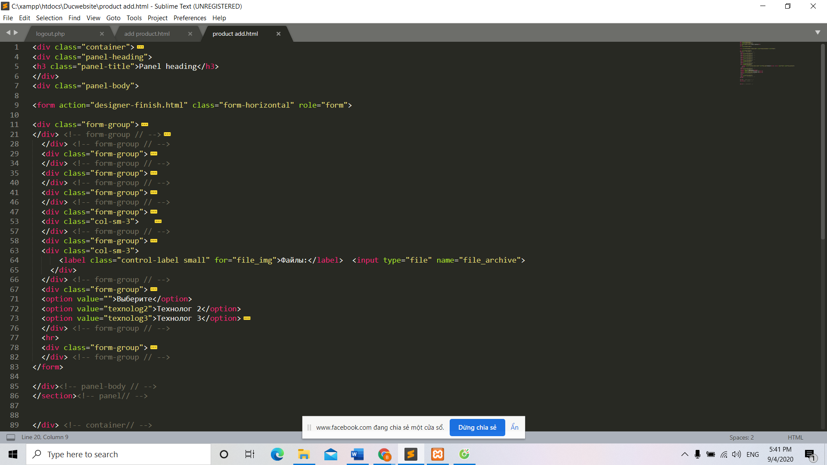

Add product

**Edit product**

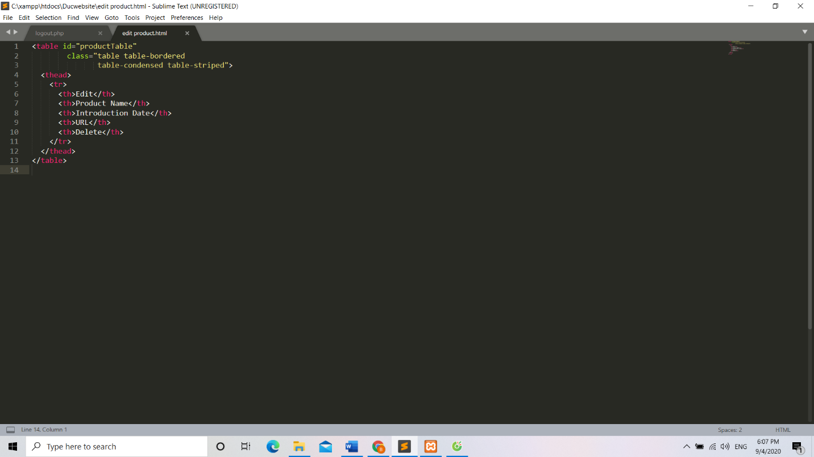

Edit product

1. **CONCLUSION**

The Internet has become a major resource in modern business, thus electronic shopping has gained significance not only from the entrepreneur’s but also from the customer’s point of view. For the entrepreneur, electronic shopping generates new business opportunities and for the customer, it makes comparative shopping possible.

As per a survey, most consumers of online stores are impulsive and usually make a decision to stay on a site within the first few seconds. “Website design is like a shop interior. If the shop looks poor or like hundreds of other shops the customer is most likely to skip to the other site. Hence we have designed the project to provide the user with easy navigation, retrieval of data and necessary feedback as much as possible. In this project, the user is provided with an ecommerce web site that can be used to buy books online. To implement this as a web application we used ASP.NET as the Technology. ASP.NET has several advantages such as enhanced performance, scalability, built-in security and simplicity.

To build any web application using ASP.NET we need a programming language such as C#, VB.NET, J# and so on. C# was the language used to build this application. For the client browser to connect to the ASP.NET engine we used Microsoft’s Internet Information Services (IIS) as the Web Server. ASP.NET uses ADO.NET to interact with the database as it provides in-memory caching that eliminates the need to contact the database server frequently and it can easily deploy and maintain an ASP.NET application. SQL was used as back-end database since it is one of the most popular databases, and it provides fast data access, easy installation and simplicity.

A good shopping cart design must be accompanied with user-friendly shopping cart application logic. It should be convenient for the customer to view the contents of their cart and to be able to remove or add items to their cart. The shopping cart application described in this project provides a number of features that are designed to make the customer more comfortable.

This project helps in understanding the creation of an interactive web page and the technologies used to implement it. The design of the project which includes Data Model and Process Model illustrates how the database is built with different tables, how the data is accessed and processed from the tables. The building of the project has given me a precise knowledge about how ASP.NET is used to develop a website, how it connects to the database to access the data and how the data and web pages are modified to provide the user with shop aplication.

1. **References**

Anne Boehm, Joel Murach, Murach’s ASP.NET 4 Web Programming with C# 2010, 4th Edition, Murach, 2010.

Bryan Syverson, Joel Murach, Murach’s SQL Server 2012 for developers, Murach, 2012.

Components of a Website. Retrieved from: <https://www.stratecomm.com/faqs/components/>

Creating a website. Retrieved from: <https://www.business.qld.gov.au/starting-business/internet-start-ups/online-basics/creating-websites>

Database Design. Retrieved from: <https://www.inventica.co.uk/database-design/?gclid=CjwKCAjwqML6BRAHEiwAdquMnZcOA7A2RBz68hMzaLDRZN0GA0WNOlEy0NKjnzkrctp5Ht52KZ2cChoCKEsQAvD_BwE>

QA Process: How the QA Team Tests Your Project. Retrieved from: https://kruschecompany.com/quality-assurance-in-projects/

Single page vs multi-page websites: Design battle! Retrieved from: <https://www.justinmind.com/blog/single-page-vs-multi-page-websites-design-battle/>